**PARALLEL & DISTRIBUTED COMPUTING**

**BFS ORDER USING MPI**

**TEAM MEMBERS:**

**Deepak Sadh 19k-0353**

**Sandeep Kumar 19k-0216**

**SECTION: BCS - 6E**

**Introduction:** Breadth-First Search/Level-wise Sort (BFS) is one of the most fundamental graph algorithms used as a component of many graph algorithms.

Breadth-First Search algorithm is a graph traversing technique, where you select a random initial node (source or root node) and start traversing the graph layer-wise in such a way that all the nodes and their respective children nodes are visited and explored.

Before we move further and understand Breadth-First Search with an example, let’s get familiar with two important terms related to graph traversal:

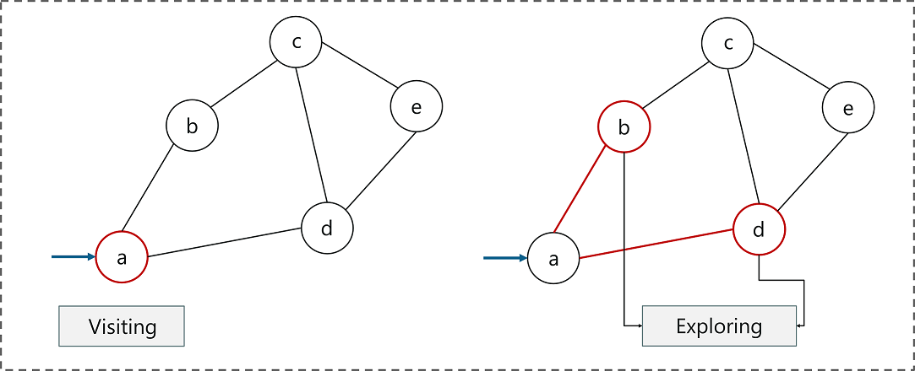

1. Visiting a node: Just like the name suggests, visiting a node means to visit or select a node.
2. Exploring a node: Exploring the adjacent nodes (child nodes) of a selected node.

**Objective:** We will distribute the data set of given vertices Vertex wise and execute them parallelly using distributed computing and use message passing to Communicate while calculating BFS.

**Methodology:** Firstly we broadcast no of vertices to all the processes, then we scatter the adjacency matrix each process is assigned a vertex, then all the processes tell us adjacent vertices of the assigned vertex and all the adjacent vertices are gathered back into BFS array. After that Parent Process follows the BFS algorithm by using Queue and prints the data in BFS order.

**Applications:**

Breadth-first Search is a simple graph traversal method that has a surprising range of applications. Here are a few interesting ways in which Bread-First Search is being used:

**Crawlers in Search Engines:**

Breadth-First Search is one of the main algorithms used for indexing web pages. The algorithm starts traversing from the source page and follows all the links associated with the page. Here each web page will be considered as a node in a graph.

**GPS Navigation systems:**

Breadth-First Search is one of the best algorithms used to find neighboring locations by using the GPS system.

**Find the Shortest Path & Minimum Spanning Tree for an unweighted graph:**

When it comes to an unweighted graph, calculating the shortest path is quite simple since the idea behind the shortest path is to choose a path with the least number of edges. Breadth-First Search can allow this by traversing a minimum number of nodes starting from the source node. Similarly, for a spanning tree, we can use either of the two, Breadth-First Search or Depth-first traversal methods to find a spanning tree.

**Broadcasting:**

Networking makes use of what we call as packets for communication. These packets follow a traversal method to reach various networking nodes. One of the most commonly used traversal methods is Breadth-First Search. It is being used as an algorithm that is used to communicate broadcasted packets across all the nodes in a network.

**Peer to Peer Networking:**

Breadth-First Search can be used as a traversal method to find all the neighboring nodes in a Peer to Peer Network. For example, BitTorrent uses Breadth-First Search for peer to peer communication.

**Conclusion:** The benefit of finding BFS using MPI instead of Serial is that we can find adjacent nodes of each vertex parallelly while we would have to do that by repetition in serial.Breadth Search Algorithm comes with some great advantages to recommend it. One of the many applications of the BFS algorithm is to calculate the shortest path. It is also used in networking to find neighbouring nodes and can be found in social networking sites, network broadcasting, and garbage collection. The users need to understand the requirement and the data pattern to use it for better performance.

**Graph:**

